Future tech 5g virtual zero latency
V.Nikitha¹, UG Scholar, Manoj Kumar D S², Assistant Professor
Department of Computer Science and Engineering
Saveetha School of Engineering,
Saveetha University

ABSTRACT : With the point of conveying any data in whenever and anyplace, the people to come (5G) remote communication systems turn into a style theme in the remote examination territories and new waveform, as one of the key empowering advances in 5G physical layer, pulls in developing exploration considerations lately. Be that as it may, the current method for waveform examination or investigation depends on the change of range productivity or use, while the majority of them neglects to research the vitality proficiency conduct, which is appeared to be the key execution metric of 5G frameworks. In this paper, the most part is concentrated on looking over the waveforms from the vitality proficiency perspective. Two classifications of waveforms, specifically channel based waveform and spreading-based waveform, are broke down and the related execution issues are talked about. Besides, we actualize the above waveforms utilizing programming characterized radio based model stage and produce the estimation results for the vitality productivity correlation.
- KEYWORDS :
List Terms—5G, vitality proficiency, waveform, OFDM, non-orthogonal various access
- INTRODUCTION :
It has been over thirty years for the versatile and remote correspondences to create from the customary Global System for Mobile interchanges (GSM) to the recently propelle
Long Term Evolution Advanced (LTE-A) systems. With the point of conveying any data in at whatever time and anyplace, overall remote specialists begin to consider what the people to come (5G) remote communication systems resemble. For instance, the European Union started a coordinated undertaking in the seventh structure program (FP7) named "Portable and remote correspondences Enablers for the Twenty-twenty Information Society (METIS) " , which means to establish the framework of 5G versatile and remote interchanges framework, and the U.S. national science establishment (NSF) has additionally chosen to give NYU-Wireless and Auburn college to "pick up a profound comprehension" of 5G radio interchanges . In the mean time, in the mechanical zone, both merchants and administrators are persuaded to explore their interior exploration programs and effectively joining shared examination ventures for 5G remote correspondences, including Ericsson, Huawei, T-Mobile and different accomplices.
New waveform, as one of the key empowering innovations in 5G physical layer, draws in developing examination considerations lately. With a specific end goal to meet the 5G transmission requirements on omnipresent access and dangerous movement development, new waveform examination is experiencing an outlook change from orthogonal to non-orthogonal outline approaches. Low cave sity signature based orthogonal recurrence division multiplexing (LDS-OFDM) is one case to use the non-orthogonality property for association change. Another competitor called "channel bank multi-bearer (FBMC)" is additionally proposed to accomplish the dynamic range use by creating the non-orthogonality between the neighbouring subcarriers. All things considered, the current method for waveform research concentrates on the change of range proficiency or use, while the greater part of them neglects to examine the vitality productivity conduct , which is appeared to be the key execution metric of 5G frameworks .
In this article, we for the most part concentrate on the recently proposed wave-structure innovation for 5G transmission. General discourses on green parts of 5G cell systems are given in and competitor waveforms of 5G, for example, Generalized Frequency Division Multiplexing (GFDM) and FBMC, are investigated in [8]. Not quite the same as the past written works, we talk about those competitor waveforms from the vitality proficiency (EE) perspective. In particular, summed up handset designs are initially presented with the relating power models. Next, new sorts of waveforms with the vitality proficiency consider-ation are talked about, where we arrange them into two sections, to be specific the separating based waveform and the spreading-based waveform. Some handy constraints and usage difficulties of new waveforms are additionally expounded to give a complete perspective. For reasonable correlation, we actualize the above waveforms utilizing the same programming characterized radio (SDR) based model stage and create the throughput estimation results and in addition the force utilizations. We then finish up this article with some opening exploration issues.
- SUMMED UP STRUCTURE AND BASELINE :
Without loss of all inclusive statement, we consider a summed up multi-client handset structure of remote frameworks as appeared in Fig. 1, including the channel coding/unravelling, the force adaptation/levelling and additionally the sifting/defiltering squares. The quantity of clients and asset components are de-noted by K and N individually. In the benchmark (LTE-A) framework, K is been equivalent or not as much as N with a specific end goal to play out the orthogonal remote transmission, while in the 5G physical layer, we can break this requirement by presenting the non-orthogonality in the waveform advances. As illustrated some time recently, the current non-orthogonality approaches contain
- INFRASTRUCTURESHARING:
The exponential development of worldwide information activity interest is created by billions of associated shrewd gadgets. More- over, the presentation of new correspondence sorts such as machine-to-machine correspondence is further accelerating this pattern. To meet these requests, not just do a huge number of new BSs should be sent each year, be that as it may, the accessible range additionally should be esteemed and utilized effectively. Spurred by such patterns and variables, base sharing is turning into the prerequisite for vitality and cost proficiency. System sharing is likewise stud- ied in . Specifically, diverse centre system administrators are permitted to interface with a radio access system, where both system components and radio assets are shared. Additionally, expounds on various situations and use cases of administrators'
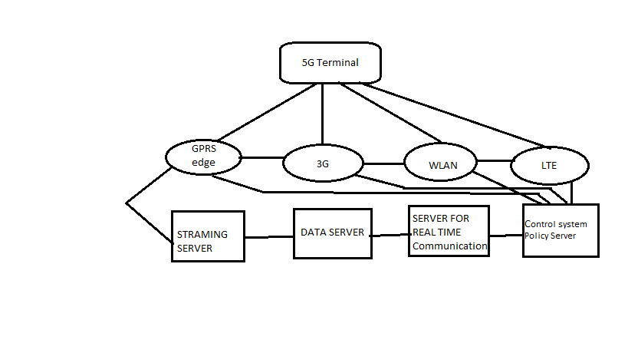
radio sharing, bringing up the methods for proficient asset sharing. Business perspectives and economic advantages of and drivers and boundaries for system shaR ing are examined in , while the creators of research the ebb and flow mechanical arrangements and regu- latory and techno-monetary parts of sharing versatile media transmission systems in a developing business sector con- content. The creators of give a superior comprehension what's more, represent the significance of framework sharing for distinctive access system advancements, in both urban and rustic ranges. Plans of action for asset administration in system sharing situations and financial effects on OPEX and CAPEX are exhibited
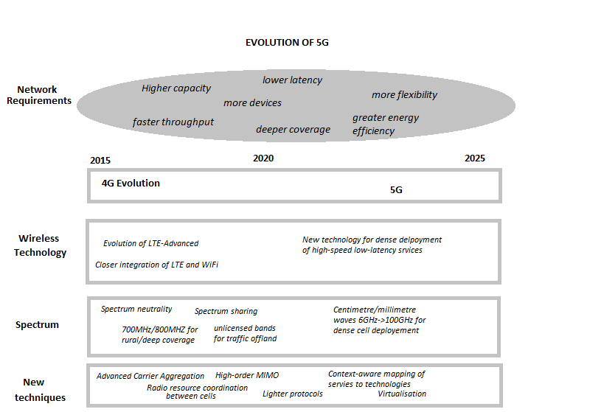
For the assessment of such ideas, broad framework level reproductions are led. An exclusive framework level reproduction instrument, which is being worked on, is utilized for checking different parameters, for example, movement level, hub sharing, accessible foundation elements, and range per administrator, and it assesses the different experiments. The setup is completely adjustable to incorporate different sorts of cells (i.e., macrocells and little cellS.) Specifically, it is conceivable to custom- ize the accompanying: the measure of play area, the range sort (e.g., Dense Urban), the number and position of macintosh ro-BSs and their intersite separations, the number and position of little cells per full scale BS, the number and position of end-client gadgets in the play area, and the number of accessible administrators. Furthermore, the way LOSS.When uniform activity is considered (without the use of hot zones—as an illumination, we consider that, in hot zones, clients are concentrated around little cells), the vitality productivity is assessed by looking at an essential scenario (i.e., no sharing perspectives—where each of the four accessible administrators in a territory works its own particular physical framework.
As per the previously mentioned results, the meaning of vitality productivity is the change in the proportion. While cutting edge cell systems worked by various suppliers have the ability to perform well inside the standard QoS edge that the innovation requests, this is accomplished with conceivable vitality proficiency, the most minimal force utilization, and enhanced QoS/execution. The advantages from the vitality proficiency can bring about lower OPEX, and it can likewise be recapitalized for further QoS enhancements that conquer any hindrance between the fourth era and 5G. wastefulness, underutilization of the radio abilities, what's more, over provisioning
- CLIENTS ARE CONCENTRATED TO PARTICULAR SPOTS,FURTHER MORE,CAN BE PRESENTED WITH THE EXPANSION OF LITTLE CELLS TO THESE HOT ZONES :
. In our endeavours to enhance the energy productivity of these systems, we are breaking this study into three particular reproduction stages:
1) the assessment of the reference situation (i.e., the sce nario we are attempting to make strides
2) stage 1, in which we are impairing the base of three suppliers while keeping the activity request at the same level—in this connection, every situation has an balanced little cell number (put consistently), pointing to ingest the system request regarding QoS
3) stage 2, in which the populace thickness spatial distribution is checked in the situation of the offloading picocells; taking after the same recreation trials as stage 1, we continue with the choice of the number of little cells for the hot zones.
In stage 1, the normal aggregate force utilization of the system quickly decreases as a substantial number of components are as a rule totally incapacitated. We can likewise hope to see a decrease in the QoS of the clients that outcomes from the sudden absence of accessible system assets in the macrolayer. Notwithstanding, as the quantity of little cells 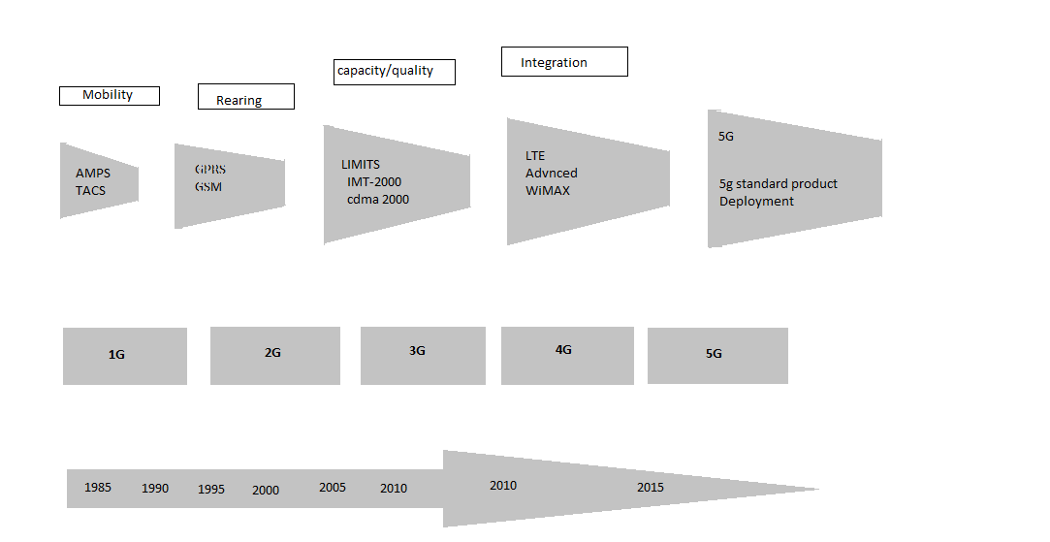scope zone of these cells encounter a change in QoS while the force utilization is kept at low levels. The situation of little cells, be that as it may, requires a more intelligent outline as opposed to stacking a substantial amount of components since it experiences.

the negative impacts of impedance. This commands the little cell radio environment and goes about as an offset for the change in QoS. In this manner, in stage two, less little cells are chosen, however they are set in more vital areas (problem areas). There, they accomplish the most noteworthy conceivable vitality proficiency, the least power utilization, and enhanced QoS/execution. The advantages from the vitality productivity can bring about lower OPEX, and it can likewise be recapitalized for further QoS enhancements that cross over any barrier between the fourth era and 5G.
- THE CONVENCTIONAL RIM SCHEMES :
Beginning from the exploration in a magnificent exertion has been paid to outline obstruction administration points of view, particularly the joint cell affiliation and force control(JCAPC) plans in a multi-level 5G RAN framework. Some of these intriguing RIM plans are talked about as take after
- .ADVANCED INTERFERENCE MANAGEMENT SCHEME :
keeping in mind the end goal to address co-channel impedance issues occuring inside BSs of UDNs and meet requests of touchy movement volumes related QoS execution, (for example, high information rates, more system unwavering quality, consistent versatility, high security and protection and low inactivity), has proposed a propelled obstruction administration (AIM) procedure. With the AIM approach, the obstruction administration at the client gear (UE)- side is similarly weighted with that of the system side impedance administration (i.e, upstream from the D2D system). The principle thought is to make every recipient (i.e., UE) fit for exploiting the structure of the obstruction signals, including tweak group of stars, coding plan, channel and asset allocation. In this way, every collector tries to identify and decode images of the impedance signals with a specific end goal to recognize the solid co-channel obstruction among neighbouring cells from the warm clamour in its factual and physical attributes. Once decoded, the obstruction signs can be recreated in light of the locator/decoder yield and crossed out from the got sign to enhance the craved sign interpreting execution, for example, high information rates
- CONCLUSION:
This article explored the advantages of asset sharing in 5G settings: current status and prospects. The simulation results have demonstrated that, in a four-administrator environment, when the administrators are served by the base of one, noteworthy vitality additions of around half can be accomplished while keeping up the quality that was accomplished before the foundation sharing. Future work ought to incorporate the improvement and assessment of new answers for accomplishing asset productivity by capitalizing on the idea of range sharing as well.In synopsis, we have reviewed two sorts of new wave-shapes from the EE perspective. Through hypothetical studies, both the spreading-based and sifting based waveforms show better EE execution over the customary LTE-A based methodology. To check the systematic results, we have actualized all the previously mentioned waveforms through the SDR stage, where the estimation results demonstrate the same conduct particularly in the medium or high SNR administration.
- REFRENCES:
[1] N. Bhushan et al., “Network densification: The dominant theme for wire-less evolution into 5G,” IEEE Commun. Mag., vol. 52, no. 2, pp. 82–89,Feb. 2014.
[2] O. G. Aliu, A. Imran, M. A. Imran, and B. Evans, “A survey of self organisation in future cellular networks,” IEEE Commun. Surveys Tuts., vol. 15,no. 1, pp. 336–361, Feb. 2013.
[3] R. Razavi, M. AL-Imari, M. A. Imran, R. Hoshyar, and D. Chen,“On Receiver Design for Uplink Low Density Signature OFDM (LDS-OFDM),” IEEE Trans. Commun., vol. 60, no. 11, pp. 3499 – 3508, Nov.2012.
[4] B. Farhang-Boroujeny, “OFDM Versus Filter Bank Multicarrier ,” IEEE Signal Process. Mag., vol. 28, no. 3, pp. 92 – 112, May 2011.
[5] Y. Chen, S. Zhang, S. Xu, and G. Y. Li, “Fundemantal Tradeoffs onGreen Wireless Networks,” IEEE Commun. Mag., vol. 49, no. 6, pp. 30– 37, Jun. 2011.

