Automated Attendance System Through Eigen Faces Using Image Processing

M. SreeVidya¹, K. Arul²
UG scholar¹, Assistant Professor²,
Department of Computer Science and Engineering
Saveetha School of Engineering
Saveetha University

Abstract-- Eigen faces(PCA) approach for face recognition ,The face is an important part of who you are how people identify you. In face recognition there are two types of comparisons verification and identification. There are about 80 nodal points on a human face here are few nodal points that are measured by software that are distance between eyes ,width of the nose, Depth of the eye socket, Check bones, Jaw line and Chin By this method we can take automatic attendance .face recognition is done by projecting new image onto a low dimensional linear “face space” defined by the Eigen faces. This method is reliable , low cost , faster access and reduce man power.
Keywords-- face space, recognition, nodal points, Eigen faces
- INTRODUCTION
Eigen faces refer to an appearance-based approach to face recognition that seeks to capture the variation in a collection of face images and utilize this data to encode and analyze images of individual faces in a holistic manner.
Eigen faces is probably one of the simplest face recognition methods and also rather old, then why worry about it at all? Because while it is simple it works quite well. And its simplicity also makes it a good way to understand how face recognition/dimensionality reduction extra works.
Facial acknowledgment technologies can recognize identity of an individual even without any direct communication between the system and the user. This is conventionally done by taking or capturing a sample of image of the individual using cameras .

Biometrics supports in authenticating the character of an individual through physiological or behavior distinctiveness Further precisely, conventional authentication methods such as magnetic cards, passwords, keys and personal identification cards are pathetic towards any threat and can be stolen without much effort. Biometrics technology acknowledges an extends a simple and secure authentication.
- LITERATURE SURVEY
- Comparison of the two approaches:
In Nearest neighbor training time is much faster, storage is same, classification time is slightly slower.
Accuracy : neutral network is able to achieve the same accuracy using 5 Eigen faces with nearest neighbor using 15, and a higher accuracy when using 15.
- PCA:
Main statement of PCA approach:
Face space forms a group in image space.
PCA gives appropriate representation.
Eigen Face approach:
- Eigen Space and Eigen faces:
face images are projected into a feature space (“Face Space”) that best encodes the difference among known face pictures.
The face space is defined by the “Eigen faces”, where Eigen faces are the set of faces in Eigenvectors
- Steps for face recognition:
- Initialization
- Acquire the training set and calculate Eigen faces (using PCA projections) which define Eigen space.
- When a new face is encountered , calculate its weight.
- Determine if the image is face.
- If yes , categorize the weight pattern as known or unknown .
- (Learning ) if the same unknown face is seen many times integrate it into known faces.
- Statement:
Given an image , to identify it as a face and/or extract face image from it.
To retrieve the similar pictures from the given database of face images.
- Face recognition has different potential applications, such as
1.Person identification
2.Human-computer interaction
3.Security system
vii. Stages of face recognition:
1. Face location detection
2. feature extraction
3. facial image classification
viii. Aroaches of feature extraction:
- Local : Distance between eyes, width of the nose, mouth information easily affected by irrelevant information.
- Global : Extract feature from whole image
ix. Eigen Face Space:
face recognition is done by projecting new image onto a low dimentional linear “face space” defined by the Eigen faces.

- IMPLIMENTATION
- Eigen face Method With PCA:
Main assumption of PCA approach:
Face space forms a group in image space.
PCA gives appropriate representation
Principal Component Analysis (PCA):

A N x N pixel picture of a face, represented as a vector occupies a single point in N²-dimensional picture space.
Images of faces being alike in overall configuration, will not be randomly distributed in this enormous picture space.
Therefore, they can be defined by a low dimensional subspace.
Foremost hint of PCA for faces:
To find vectors that best account for variation of face picture in entire picture space These vectors are known as Eigenvectors.
Construct a face space and project the picture into this face space (Eigen faces).

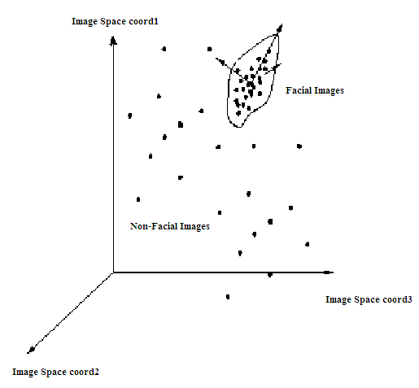
Picture Representation:

Training set of m images of size N*N are represented by vectors of size N²
x₁,x₂,x₃,…,x_{M}

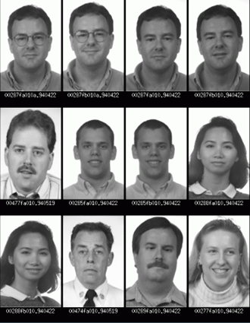
example:

Average picture and Difference picture:
The average training set is defined by
m= (1/m) ∑^{m}_{i=1} x_{i}

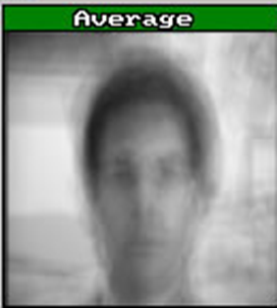

Each face differs from the average by vector
r_{i} = x_{i} – m
- Eigenvalues and Eigenvectors:
If v is a nonzero vector and λ is a number such that
Av = λv, then
v is said to be an eigenvector of A with eigenvalue λ.

Example:

A
Eigen values V(Eigen vector)
Limitations of Eigen faces Approach
Variations in lighting conditions
Different lighting conditions for enrolment and query.
Bright light causing image saturation.
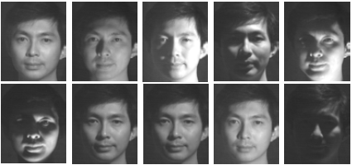
Differences in pose – Head orientation
2D feature distances appear to distort.
Expression
Change in feature location and shape.
- Calculation of Eigenfaces
(1) Compute average face : v.
(2)Gather difference between training images and average face in the matrix A (M by N), where M is the number of pixels and N is the number of pictures.
(3) Eigenvectors of covariance matrix C (M by M) produce the eigenfaces.
M is generally big, so this procedure would be time consuming.

- Calculation of The Eigenvectors of C
If number of data points is smaller than the dimension (N<M), then there will be N-1 meaningful Eigenvectors.
Instead of directly calculating the Eigenvectors of C, we shall calculate the Eigenvalues and the corresponding Eigenvectors of a smaller matrix L (N by N)
if λ_{i} are Eigenvectors of L then A λ_{i} are Eigenvectors for C.
The Eigenvectors are in the descent order of corresponding eigenvalues.

- Representation of Face pictures using Eigen faces:
The training face pictures and new face pictures can be represented as linear combination of the Eigen faces.
When we have a face image of u :

- Since the Eigenvectors are orthogonal :

Note: In what ever direction you are it ill calculate your distance between eyes ,width of the nose, Depth of the eye socket, Check bones, Jaw line and Chin.
- Neural Networks and TS-SOM:
- Newral Network
Single units to simulate Neurons
Simultaneously Processing
Several inputs and Single output
- SOM:
TS-SOM :- Tree structure self-organizing maps
Each unit of map takes identical inputs
Units competes for selection
Change of selected node and its neighbors
- Training of SOM:
- Randomly initialized
- Selection based on few query parameter
- On selection a node and its neighbors are changed
- Degree of change reduces with each iteration
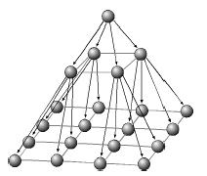
Example of a 2-D TS-SOM structure of 3 levels
- Algorithm:
- Calculate weight vector for 1st level.
- Initialize weight vectors of next levels.
- Calculate centroid associated to every node as mean of closest training samples.
- Iterate for the next level.
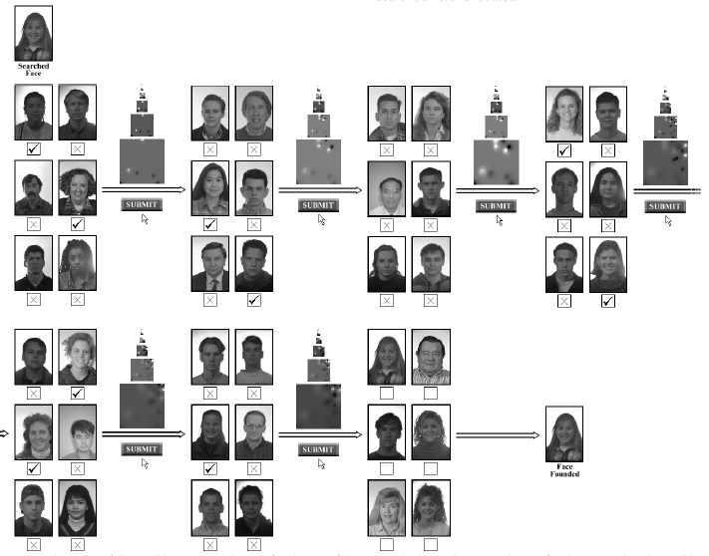

- CONCLUSION AND FUTURE WORk:
Face Detection in motion images.
Complete study of the proposed system assuming PCA assumptions not to be true.
Investigate whether Eigen faces is a good solution for this problem by comparing with other feature extraction techniques such as DCT
An Eigen faces-based face recognition approach was implemented in MAT LAB.
This method represents a face by projecting real images onto a low-dimensional linear subspace—‘face space’, defined by Eigen faces. A new face is equated to known face classes by computing the distance between their projections onto face space.
From clarifications, it has proved that only 15% of Eigen faces with the largest Eigen values are enough for the recognition of a person’s face. We can conclude that the test image is absolutely matched with the existing image in the database.
Eigen faces for face recognition is best approach for automated attendance system . it is simple , less cost , reliable , reduces man power.

References:
[1] Navarrete P. and Ruiz-del-Solar J. (2002), “Interactive Face Retrieval using Self-Organizing Maps”, 2002 Int. Joint Conf. on Neural Networks – IJCNN 2002, May 12-17, Honolulu, USA.
[2] “A tutorial on Principal Components Analysis”, By Lindsay I Smith.
[3] “Eigenfaces for Recognition”, Turk, M. and Pentland A., (1991) Journal of Cognitive Neuroscience, Vol. 3, No. 1, pp. 71-86.
[4] Ruiz-del-Solar, J., and Navarrete, P. (2002). “Towards a Generalized Eigenspace-based Face Recognition Framework”, 4th Int. Workshop on Statistical Techniques in Pattern Recognition, August 6-9, Windsor, Canada.
[5] Simulating Neural Networks by James A. Freeman. Artificial Intelligence by Neil J. Nielsson. Turk, M., Pentland, A.:
[6] Eigenfaces for recognition. J. Cognitive Neuroscience 3 (1991) 71–86.
[7] “Eigenfaces for recognition”, M. Turk and A. Pentland, Journal of Cognitive Neuroscience, vol.3, No.1, 1991

[8] “Face recognition using eigenfaces”, M. Turk and A. Pentland, Proc. IEEE Conf. on Computer Vision and Pattern Recognition, pages 586-591, 1991

[9] “Human face segmentation and identification”, S. A. Sirohey, Technical Report CAR-TR-695, Center for Automation Research, University of Maryland, College Park, MD, 1993

[10] “Automatic recognition and analysis of human faces and facial expressions: A survey”, A. Samal and P. A. Iyengar, Pattern Recognition, 25(1): 65-77, 1992

[11] “Low dimensional procedure for the characterization of human faces”, Sirovich, L. and Kirby, M, Journal of the Optical Society of America A, 4(3), 519-524

[12]“Face recognition for smart environments”, A. Pentland and T. Choudhury, Computer, Vol.33 Iss.2, Feb. 2000

[13]“Human and machine recognition of faces: A survey”,R. Chellappa, C. L. Wilson, and S. Sirohey, Proc. of IEEE, volume 83,

