URBAN TRAFFIC SIMULATORS

CHITLA HARSHITHA [1],
B.E COMPUTER SCIENCE AND ENGINEERING,
SAVEETHA SCHOOL OF ENGINEERING,
SAVEETHA UNIVERSITY, CHENNAI,
TAMIL NADU, INDIA,
harshipuppy8@gmail.com.

R.GIRISRINIVAAS [2],
B.E. COMPUTER SCIENCE AND ENGINEERING,
SAVEETHA SCHOOL OF ENGINEERING,
SAVEETHA UNIVERSITY, CHENNAI,
TAMIL NADU, INDIA,
girividhur@gmail.com.

V. PARTHIPAN ^{[3]},
DEPARTMENT OF COMPUTER SCIENCE AND ENGINNERING,
SAVEETHA SCHOOL OF ENGINEERING,
SAVEETHA UNIVERSITY, CHENNAI,
TAMIL NADU, INDIA,

ABSTRACT: − Computer traffic simulation is a widely used technique in modeling, coming up with and development of traffic networks and systems. It contains a various applications, like traffic forecasting, vehicle navigation devices and so on. This paper discusses about the various types of traffic simulators. Another drawback is that the factors like accidents, public events, and road closures. In addition, we are introducing algorithmic concepts, quantifiable metrics and data structural approaches that might be applied to the simulation systems.

Keywords: Traffic simulation, vehicular traffic, software review, metrics, algorithm.

- INTRODUCTION
Traffic simulation systems are initiated over 40 years ago and it is very important for traffic and transportation designing in today’s world. Simulation is famous method in the area of science. Traffic simulators are used to design the transportation system model virtually using the computer software package. Transportation system modeling uses these simulating environments to verify the transportation models in order to prove their properties. Nowadays large mechanical power provides individuals the ability to simulate an environment quicker than the real environment.

2. TRAFFIC SIMULATION MODELS
Traffic simulator modeling is a famous and effective tool for analysis of dynamical issues in the complex processes which can’t readily be described in the analytical terms. These complex processes are characterized by the communication of system elements that interactions are complicated in nature. Simulators models are the mathematical representations of the real-world systems which takes the shape of simulation software package that are executed on a computer as an experiment.

3. NESSASITY FOR TRAFFIC SIMULATORS
Traffic simulator model has a verity of applications in the verity of fields. Nowadays simulators become important tool for research and interpretation of real world environment particularly in the traffic engineering. The subsequent situations where traffic simulation model will notice their scope. When an analytical treatment of a problem is found an inadequate due to its complicated nature. The traffic simulators are used in large variety of applications like evaluation of alternative treatments and testing new designs as an entity of the design process, embedded in other tools, safety analysis and so on.

4. CATEGORIES OF TRAFFIC SIMULATION MODEL

4.1 MACROSCOPIC SIMULATION MODEL
Macroscopic model don't consider car for following properties in detail; however traffic model as a mixture of fluid flow. It describes the activities and communication of entity at a low level of detail. To understand the properties of traffic analysis flow condition in a spirited way, time model, either non complicated or high-order, are sometimes used in the macroscopic simulating model. The simple traffic model contains an equation representing a link in-between the speed, density, and flow generation rate. This model was even used in the KRONOS. The traffic model doesn't consider the acceleration and the spirited speed-density relationships determined in the real world traffic flow. Although the existing model looks promising but it need not yet proven actually superior to the simple traffic models at least in medium-to-congested flow conditions.

4.2 MICRO SCOPIC SIMULATION MODEL
This type of simulation provides attention to an individual vehicle and their communications. It analysis the communication between the driver to driver on road. This supports lane changing theories and car following theories that might represent the traffic flows and vehicle behaviors in detail. This car-following theory shows the longitudinal movement of vehicle and its approach is quite simple, that is, every vehicles attempts to increases at its desired speed while maintaining a secure following distance from the vehicle ahead. The lane changing theory shows the lateral traffic behavior. This could be considered in term of variety of perception thresholds governing the consideration of the chance of accepting a gap in a neighboring lane. To generate random numbers for representing the driver/vehicle behavior in real traffic conditions.

5. CLASSIFICATION OF SIMULATION MODELS
5.1 SUMO
SUMO could be a strictly microscopic traffic simulation. It was initialized in 2001, with a primary open source release in 2002. SUMO is a traffic simulation. It is an open source, portable and microscopic road traffic simulation package designed to model the large road networks. There are 2 reasons for making it as an open source, because it can be implemented with our own algorithm. SUMO traffic simulator uses netgen for generating road network with the digital road map. Net converter is used as the road network importer, which permits reading networks from other traffic simulators. Due to the lack of applications, the support for TIGER networks was dropped.
5.2QUADSTONE PARAMICS
Quad stone Paramus could be a leading microscopic traffic and pedestrian. Paramus is the most systematically dependable traffic designing application offered nowadays. Quad stone Paramus also develops pedestrian micro simulation software package called the Urban Analytics Framework. Used in over eighty countries world-wide by thousands of consumers including commercial consultants,

5.3 VISSIM
VISSIM is a simulator used for the design of traffic control systems. It is also one of the world's leading software for microscopic traffic simulation.

5.4 SYSTEM ARCHITECTURE OF VISSIM
The first model is the traffic flow model and the second model is the signal management model. It’s the master program that sends values detected by the detector for each and every second to the signal control program.

The signal control program uses the values detected from the detector to get the present signal aspects. VISSIM receives the signal aspects and the next iteration of traffic-flow will be initiated. The traffic flow model and the signal control communicate via standardized interfaces. Flexibility is the basic advantage of splitting the 2 tasks into 2 programs.

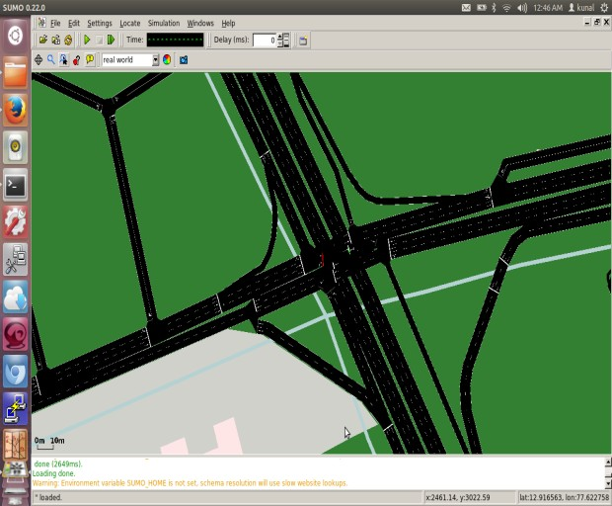
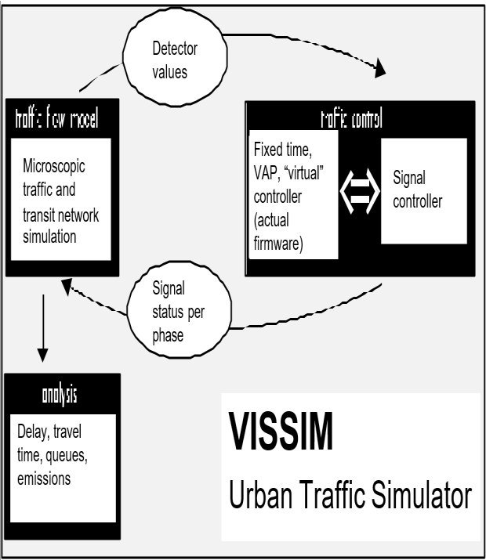

5.4.1. APPLICATIONS OF VISSIM

• It calls vehicle signal control strategies that are identical to the implementations in the controller. While testing with generated traffic flow one can test by manually starting the detectors.

- The triggering of the detectors is reported in macro files which can be used for running identical test situation with altered signal control parameters.

5.5. VISUM:

It is also one of the famous traffic simulator and
GIS –based data management. This VISUM shows all the communication of users and has become a recognized standard in transportation.

5.5.1. ADVANTAGES:

1. Investment protective
2. Strong service available
3. Descriptive and convincing results.

5.6. CORSIM:

CORSIM is a popular model for testing the situations involving in various geometric configurations, work zone impacts, and various ramp metering options. It also used for testing scenarios involving intersection style, signal coordination options, and transit modeling for exclusive lanes or mixed in traffic. It will assess advanced control situations in that the route is fixed. It models 4 verities of on-ramp freeway metering CORSIM has the most sophisticated car-following and lane- changing logic to simulate twenty nine vehicle movements on a second-by-second basic

5.7. AIMSUN 2

AIMSUN was first created by J. BARCELO and J.L. FERRER IN BARCELONA .It is a simulation tool that reproduces real traffic conditions in an urban network that contains expressways and arterial routes. AIMSUN provides the flow, speeds, travel times etc., of a vehicle. It distinguishes between various types of vehicles and drivers. AIMSUN2 has been joined to UK scoot UTC system. It is traffic simulator that permits you to design one traffic lane to a complete region. In this real-world application AIMSUN2 passed details of traffic flow to scoot and uses the data that was returned to it from the analysis. The most recent version - AIMSUN eight.
1 - was released in June 2015. Economical software package development makes micro simulation with AIMSUN each sensible and cheap, even on today’s portable computer

5.8. MATSIM (MULTI AGENT MICRO- SIMULATION)

It provides a framework to implement large- scale agent-based transport simulations. The framework consists of various modules which might be combined or used complete. Modules may be replaced by own implementations to check single aspects of your own work. Currently, MATSIM offers a framework for demand-modeling, agent-based mobility-simulation (traffic flow simulation), replanting, and a controller to iteratively run simulations as well as strategies to research the output generated by the modules.
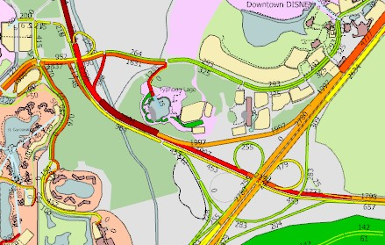

6. CONCLUION

The traffic simulator is the largely used method for simulation of the traffic conditions in the particular area. The above mentioned simulators are commonly used for the traffic simulation and there advantages and disadvantages are also mentioned in this paper. Using these simulators the road network is designed and the traffic condition is explained in a particular area.

In future we are going to implement this simulator for designing the traffic level management system, which determines the traffic conditions in the area where the user is traveling and it will suggest the alternative shortest path to the road takers using the spatial visualization.

REFERENCE

[1] Simulation of urban traffic control: A Queue Model approach D. Greeter, A. Neumann, K. Nagel Transport Systems Planning and Transport Telematics, Berlin Institute of Technology, Salzufer 17-19, D-10587 Berlin, Germany, Tel: 49-30-314 21383, grether@vsp.tu-berlin.d.

[2] C.Meneguzzer,Review of models combining traffic assignment and signal control, Journal of Transportation engineering 123(2).
[3] Traffic Management based on Data Extraction and Visualization, T. Rajasekaran, Dr. A. Rengarajan.

[4] EFFICIENT ROUTE FINDER SYSTEM SanjayKumar Yadav1 , Madhavi Singh2 1Assistant. Professor, Department of Computer Science and IT, SHIATS, Allahabad, U.P, India 2M.Tech. Scholar, Department of Science and IT, SHIATS, Allahabad, U.P, India, International Journal of Computer Engineering and Technology (IJCET), ISSN 976-
[5] 6367(Print), ISSN 0976 – 6375(Online) Volume 4, Issue 4, July-A.
[6] Brian MAK and Hong K. LO, Passenger Route Guidance System for multimodal transit networks, The Hong Kong University of Science and Technology, Hongkong
[7] Overload Traffic Management for Sensor Networks, ACM Transactions on Sensor Networks, Vol. 3, No. 4, Article 18, Publication date: October 2007.

